##### RTL Implementation of Low Power Error Tolerant Approximate Multiplier for Image Compression and Decompression

##### SUMMER RESEARCH INTERNSHIP REPORT



###### ***Submitted by***

##### BIBHUPAD TRIPATHY

IN

ELECTRONICS AND COMMUNICATION ENGINEERING

NATIONAL INSTITUTE OF SCIENCE AND TECHNOLOGY (Autonomous)

INSTITUTE PARK, PALLUR HILLS, BERHAMPUR-761008

MAY-JULY,2019

**BONAFIDE CERTIFICATE**

This is to certify that this project report entitled “**RTL Implementation of Low Power Error Tolerant Approximate Multiplier for Image Compression and Decompression”** submitted to **National Institute of Science and Technology, Berhampur**, in connection with the NIST- Summer Research Internships & Fellowships Programs a bonafide record of work done by “**Aryan-Garg and Bibhupad Triphati”** under my supervision at the **“Mukesh Kumar sukla and Ajit kumar Panda**” from **“15-MAY-2019**” to “**15-JULY-2019” .**

Ajit Kumar Panda

Professor

Electronics and Communication Engineering

Place : NIST,Berhampur

Date : 1-JULY-2019

**ACKNOWLEDGMENT**

With deep sense of gratitude We express our sincere thanks to our esteemed and worthy project advisor **Prof. Mukesh Kumar Sukla and Prof. Ajit Kumar Panda** for their valuable guidance in carrying out this project with encouragement and cooperation.

I give my sincere thanks to **Dr. Motahar Reza, Summer Internship Coordinator,** for guiding and motivating me to complete the Internship Research project within stipulated period of time and providing a helping environment.

I acknowledge with immense pleasure the sustained interest, encouraging attitude and constant inspiration rendered by **Prof. Sukanta Mohapatra** (Chairman), **Prof. Sangram Mudali** (Director), **Prof. (Dr.) Ajit Kumar Panda** (Dean) and **Prof. Geetika Mudali (Placement Director)** N.I.S.T. Their continued drive for better quality in everything that happens at N.I.S.T. and selfless inspiration has always helped us to move ahead.

Date:1-JULY-2019

Bibhupad Tripathy

2ndYr. B.Tech

Electronics and Communication Engineering

National Institute of Technology

Rourkela

**Abstract**

Multipliers are most important parts in signal processing applications or other computationally drastic applications. Therefore, multiplier designs are mainly focused on high-speed, low area and low power. These parameters are achieved by approximate multipliers. Generally, approximate computing has a significant attention as a rising strategy to decrease power consumption of error tolerant applications like image processing, search engines, video processing. Approximate computing has been advocated as a new approach to saving area, as well as increasing performance at a limited loss in accuracy [3]. In this paper we discuss the various surveys (study) of different approximate multiplier and compare it with accurate multipliers.

The main purpose of approximate computing is to decrease the power consumption and delay at run time in those processes which can tolerate error to some extent.

**Contents**

|  |  |  |
| --- | --- | --- |
| Sl. No | Contents | Page No |
| 1 | Introduction | 6 |
| 2 | Review of Literature/ Theoretical Background | 6 |
| 3 | Objectives | 21 |
| 4 | Research Methodology | 21 |
| 5 | Data Analysis , Results and Interpretation | 21 |
| 6 | Conclusions | 25 |
| 7 | Limitations of the project | 26 |
| 8 | References | 27 |

**Introduction**

Many increasingly popular applications, such as image processing and recognition, are inherently tolerant of small inaccuracies. These applications are computationally demanding and multiplication is their fundamental arithmetic function, which creates an opportunity to trade off computational accuracy for reduced power consumption. Multipliers are key arithmetic functions for many error-tolerant applications. Approximate computing is an efficient approach for error tolerant applications because it can trade off accuracy for power, and it currently plays an important role in such application domains [1].

**Theoritical Background**

1. **Approximate Adders for Approximate multiplication:**

The adder is a basic element of most multipliers. Mahdiani et al. [2] proposed the lower-part-OR adder, which utilizes OR gates for addition of the lower bits and precise adders for addition of the upper bits. Approximate computing exploits inherent error-resilience of applications and features high-performance energy-efficient software and hardware implementations by trading-off computational quality (e.g., accuracy) for computational efforts (e.g., performance and energy). In [3], a comparative survey of state of-the-art approximate adders is provided. And it also provides comparison based on both conventional design metrics as well as approximate computing design metrics.

**2.** **Carry-Maskable Adder**

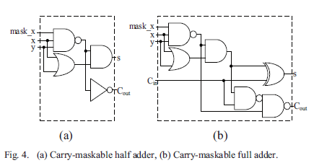

The carry-maskable adder as proposed in [5] is used to design the algorithm as described in the paper. when mask_x is 0, S is equal to x OR y and Cout is equal to 0. Otherwise, when mask_x is 1, S is equal to x XOR Y and Cout is equal to x AND y. In other words, the operation of the proposed half adder can be controlled by the active-low signal mask_x.

**3. ARCHITECTURE OF APPROXIMATE ADDER.**

**High Speed With Low Power Configurable Adder For Approximate Computing :-**

**(addition of 16-bits)**

As Adders are the basic units of the multipliers so we have constructed an approximated adder which will make use of Carry Maskable Adders as their basic units .

So there are four CMHA(Carry Maskable Half Adders) are used in this circuit .

-> CMHA1 :- in1[3:0] and in2[3:0]

-> CMHA2 :- in1[7:4] and in2[7:4]

-> CMHA3 :- in1[11:8] and in2[11:8]

-> CMHA4 :- in1[15:12] and in2[15:12]

Then the answers of these individual adders will be atmost of 5 bits then they will be sent to CLA (Carry Lookahead Adder) and then we will get the approximated answer .



This is the main architecture of this Approximate adder and in this we will make use of MASK signal and this is not an input, This is just a signal which will direct the adder to do the accurate sum or approximated sum.

For the MSB there is no MASK signal or the value alloted to mask signal is equal to 1.

Because we do not want any kind of approximation in these four MSB of the final answer because any mismatch with the correct answer at these positions will approximate the answer to a larger extent .

**APPLICATION :-** We can use them in doing addition of bits in the multiplier circuits .

Where the errorneous answers can be acceptable .

**4.** **Approximate Wallace Multiplier**

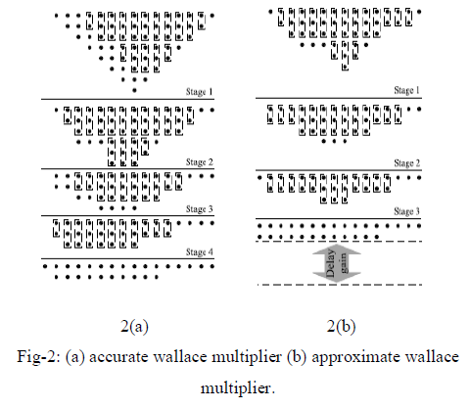

Above figure represents the algorithm for accurate and approximate Wallace tree multiplier. In accurate Wallace tree multiplier, partial products are arranged in form of triangle in **stage 1** and accurate full adder and half adder used to compress it into 6 rows as shown in diagram. Rectangles encircling 2 dots and 3 dots represents half adder and full adder respectively. In **stage 2,** full adders and half adders are used to compress it to 4 rows. In **stage 3**, full adders and half adders to compress it to 3 rows. Finally half adders are used in **stage 4** to get the results.

Approximate Wallace tree multiplier is almost similar to the accurate Wallace tree multiplier. In approximate Wallace tree multiplier, after arranging in form of triangle rows containing 11 and 5 dots are removed (This is the approximation). To preserve the accuracy of higher bits rows containing 9 and 7 elements are shifted left to arrange it in the form as shown. Further steps are similar to that of Accurate Wallace tree multiplier.

So in this approximate Wallace tree multiplier We are starting from 6 rows inspite of 8 rows as we are doing in accurate wallace tree multiplier, and due to that the compression of the partial product also require less number of gates in comparision with accurate wallace tree multiplier, which results In low power consumption and less delay.

The RTL Level structure of this Approximate Wallace multiplier is shown below.

5. **Approximate Dadda Multiplier**

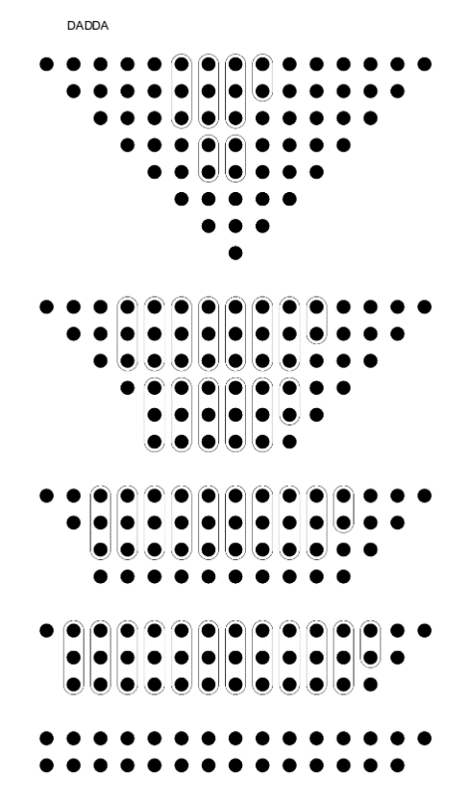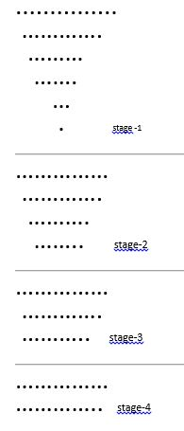

1. (b)

Fig. 3 (a) accurate dadda multiplier (b) approximate dadda multiplier

In dadda multiplier, the partial products are arranged in a triangle form as shown. Lower bits are not compressed in first 2 stages and carried forward to next stage. Full adders and half adders are used to compress 8 rows to 6 rows in stage 1. Similarly in stage 2, 6 rows are compressed to 4 rows. In stage 3, 4 rows are compressed to 2 rows. Finally the result is taken using half adders.

Similar to approximate Wallace tree multiplier, in approximate dadda multiplier rows containing 11 and 5 elements are removed to get an approximated result. To preserve higher bits rows containing 9 and 7 elements are arranged as shown. Furthers steps are same as stage 2, stage 3 and stage 4 of accurate dadda multiplier.

Approximate Dadda Multiplier can be created using two approaches :-

1. First way of creating approximate 8-bit dadda multiplier is either by removing two partial products out of 8 , or by making use of vedic algorithm .

2. In first method we have to remove the two partial product out of 8 in such a way that it will affect the accuracy of answer the least.

That's why we have removed the partial product from in2[2] and in2[3].

3. In second method we have created 8-bit approximate dadda multiplier by making use of one Accurate 4-bit dadda multiplier and three Approximate 4-bit dadda multiplier, This accurate 4- bit dadda multiplier is for the MSB bits of both the inputs and rest all the LSB will be send to approximate 4-bit dadda multiplier.



Fig :- 8-Bit Approximate dadda mutliplier RTL Schematic using three 4-bit approximate multipliers and one 4-bit accurate multiplier

**Q.** Why Dadda Multiplier is more efficient than Wallace Tree Multiplier??

Dadda Multiplier is a Improved version of wallace tree multiplier and as per dadda multiplier , He suggested why we will compress those coloumns which already contain that number of elements which we will require in next stage,

But as per wallace tree architecture, He compressed all the coloumns in every stage irrespective of the number of elements present in that coloumn .

This strategy of dadda, Results in low power consumption and high speed with similar accuracy for accurate multiplication but less accuracy in approximate multiplier than that of the Wallace tree multiplier.

**COMPARISION OF RESULTS :-**

Here we compared the results of the **approximate Eight bit Dadda Mutliplier** with that of **Accurate Eight Bit Dadda Multiplier**, As Per Accurate Dadda multiplier the answer should be different but we have approximated the answer by using one accurate 4-bit dadda multiplier and three approximate 4-bit dadda multiplier inspite of using four 4-bit accurate dadda multiplier.



**Fig. 1:- APPROXIMATE 8-BIT DADDA MULTIPLIER (simulation results)**



**Fig. 2:- ACCURATE 8-BIT DADDA MULTIPLIER (simulation results)**

So, from the simulation results we can analyse that the answer of the approximate multiplier is not equal to that of accurate multiplier, but the main advantage of using them is that we are getting less power consumption and less delay than tha accurate ones .

**Q.** The answers of approximate multipliers are always incorrect ???

No, this is not mandatory because in many cases we get the same answers for both approximate as well as accurate multipliers , Because in 4-bit approximate multipliers we are not including one partial product out of four (The middle one so that it will not affect the accuracy to a larger extend), so when the value of that corresponding bit is equal to zero then the results of both the accurate and approximate multipliers will be the same .

**6. Approximate Tree Compressor**

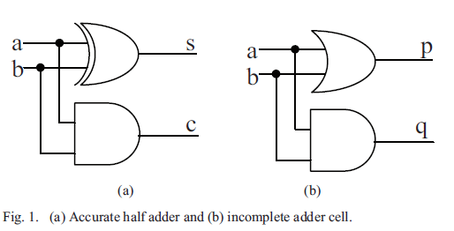

a + b = s + 2c = (s+c) +c

where + denotes addition.

The value c is generated by a AND b and s is generated by a OR b, so (c + s) can be generated by A OR b. Based on the above, consider the basic logic cell shown in Fig. 1(b), for which the following equations can be obtained:

p = s +c ,

q = c,

{c,s} = a + b = p + q,

This is called incomplete adder cell (iCAC).

Where {,} represents concatenation.

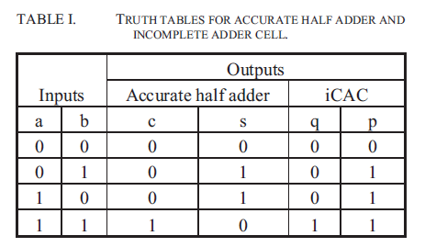

By extending the row of iCACs from two to n inputs, n/2 Ps and n/2 Qs are obtained. If the sum of the n/2 Qs is used instead of the n/2 Qs themselves, the number of Qs is reduced to one. Remember that P is always greater than or equal to S, and Q is equal to C. By exploiting these facts, OR gates can be used to generate the approximate sum of the n/2 Qs without significant loss of accuracy. This approximate sum is called the accuracy compensation vector and is denoted by V. This method is named approximate tree compressor (ATC).An ATC with n inputs is called ATC-n.

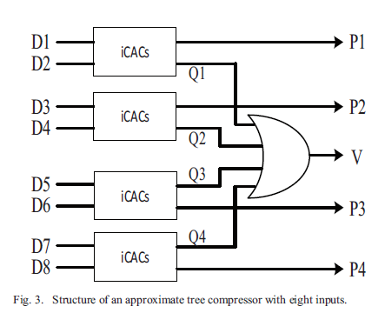

**7. Low power high speed accuracy controllable multiplier**

Based on the works of [5], an accuracy controllable multiplier is designed which uses incomplete carry maskable adders (icac). A recovery vector is generated from each icac to maintain the accuracy. At each stage icac are used and generates recovery vector v and approximate sum q. The broken line rectangle represents icacs. An n-bit multiplier consists of n rows, each of which has n partial products (PP), so there are n x n PPs in total. Using the ATC-n introduced in the previous section, the n rows can be replaced by n/2+1 rows. Figure 5 shows an example of an 8-bit multiplier with 8 x 8 PPs. The PPR is performed in three stages (Stage 1, Stage 2, and Stage 3) and the CPA is performed in Stage 4. The PP generation step is not shown. Each dot represents a PP. The least significant bit (right side) is bit 0, and the most significant bit (left side) is bit 14. The solid rectangles in Stage 1 represent ATCs and the dashed rectangles represent rows of seven iCACs. Every row of iCACs includes PPs that are not processed: for example, the PP at position 0 in the first row and the one at position 8 in the second row of the first iCAC block in ATC-8 are not processed.

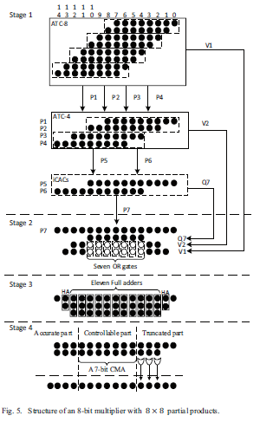

In **Stage 1**, eight rows of PPs are reduced to four rows (P1, P2, P3, and P4) and one accuracy compensation vector (V1) by an ATC-8. The four rows are further reduced to two rows (P5and P6) and another accuracy compensation vector (V2) by anATC-4. A final row of iCACs then processes P5 and P6 and generates P7 and Q7. In summary, Stage 1 uses an ATC-8, anATC-4, and a row of seven iCACs to compress the 8 x 8 PPs to four rows (P7, V1, V2, and Q7).

In **Stage 2**, there are four PPs for each of bits 4 to 10. In order to achieve a lower path delay, OR gates are used to sumV1 and V2 approximately. The empty circles for V1 and V2represent the bits which are summed using OR gates. Seven OR gates are required in total and the four rows are compressed to three.

In **Stage 3**, full adders and half adders are used to compress the three rows to two. Two half adders are required for bits 1 and 13, and eleven full adders are required for bits 2 to 12.

Addition using a carry propagation adder (CPA) is required after partial product reduction to produce the final result. In **Stage 4**, the CPA is divided into three parts in order to reduce the length of the carry propagation. Since the lower bits are not significant for accuracy, bits 0 to 4 are defined as the truncated part and three OR gates are used to generate the values for bits 2, 3, and 4 of the final result. Because there is no carry out from the truncated part, the length of the CPA is reduced to 10. Since the upper bits are the most significant for accuracy, bits 12 to 14 are defined as the accurate part, and three accurate adders are used to generate the values for these bits of the final result.

The accuracy-controllable part lies between the truncated and accurate parts. This part is important for both critical path delay and accuracy. In Stage 4, bits 5 to 11 in the CPA are replaced by a 7-bit CMA. Note that every 1-bit CMA has

a mask_x signal.



The dataset is similar that we have taken for approximate dadda multiplier but here we are not giving any preference to MSB that's why answer is deviated to such a larger extent.

**VEDIC MULTIPLICATION :-** This is a very important and useful approach to create complex architectures using the simpler ones.

Like we have created 8 bit dadda and wallace multiplier using HardCoding and to extend that 8 bit multiplication to 16-bit or 32-bit and many more this vedic algorithm is very much useful.



In the above figure "a" and "b" are inputs of 8-bits and "s" is a output of 16-bits.

In this architecture we are explaining about the 8-bit multiplication using 4-bit multipliers . If we are having 4-bit multipliers then we can make use of one 8-bit and two 12-bit adders to develop a 8*8 bits vedic multiplier.

“Urdhva-Tiryagbhyam” (Vertically and Crosswise) sutra is used to propose such architecture for the multiplication of two binary numbers. The beauty of Vedic multiplier is that here partial product generation and additions are done concurrently. Hence, it is well adapted to parallel processing.

Here as per this sutra, during the construction of 8*8 bit vedic multiplier we will make use of four 4*4 dadda multiplier as a basic unit to get the more accurate results with less power and low area consumption in comparison with 4*4 bit vedic multiplier or 4*4 wallace tree multiplier, which will be more complex than that of the 4*4 dadda multiplier.

So we will use four units of 4*4 dadda multiplier, whose functioning is described as follows:-

-> first 4*4 dadda multiplier :- in1[3:0] and in2[3:0]

-> second 4*4 dadda multiplier :- in1[7:4] and in2[3:0]

-> Third 4*4 dadda multiplier :- in1[3:0] and in2[7:4]

-> Fourth 4*4 dadda multiplier :- in1[7:4] and in2[7:4]

Here the results of all 4*4 dadda multiplier will be of 8-bits and they are stored as , temp1 , temp2 , temp3 , temp4 respectively .

Then the four LSB of temp1 will be send directly to the main output of the vedic multiplier and then the rest of the bits of temp1 will be send to 8-bit vedic adder as LSB of that.

For temp3 and temp4, as temp4 is using the MSB's of both the inputs so the shifting of bits for temp4 is 8-bits while for temp2 and temp3 it is of 4-bits so that's why due to that reason the 8-bit answer of temp3 is 8 LSB's for 12-bit adder and 8-bit answer of temp4 is 8 MSB's for 12-bit adder.

**Q.** What we will do if we have to make 32*32 bit multiplier ????

The main advantage of vedic multiplication is that we don't have to construct the algorithm for multiplication again and again , all we have to do is that we

just have to change the Adder circuit as per our need .

For example while making 32*32 bit multiplier we need four 16*16 bit multipliers ( that we already made using four 8*8 bit multiplier and one 16-bit adder and two 24-bit adder ) which results in a answer of 32-bits then one 32 bit adder and two 48-bit adder circuits are required, and then the above process will be repeated as we have done for 8*8 bit multiplication.

**Objectives**

* To implement various types of multipliers and approximate multiplier architecture in Verilog.
* After implementation analysis of power, area and delay using 180 nm standard cell library.

**Research Methodology­**

A typical multiplier consists of three parts: (i) partial product generation using an AND gate; (ii) Partial product Reduction (PPR) using an adder tree; and (iii) addition to produce the final result using a Carry propagation adder (CPA). Power consumption and circuit complexity are dominated by the PPR [7], and the multiplier’s critical path is dominated by the propagated carry chain in the CPA [8]. To survey this we implemented 7 types of existing multiplication architecture – Wallace tree multiplier (accurate and approximate), dadda multiplier (accurate and approximate),vedic multiplier and accuracy controllable multiplier[5].Each multiplier is designed stage wise using Verilog in cadence NCLaunch and is synthesized in cadence genus using 180 nm standard cell library. Power, area and critical path delay is analyzed using slow, typical and fast libraries of 180 nm standard cell library.

**Results**

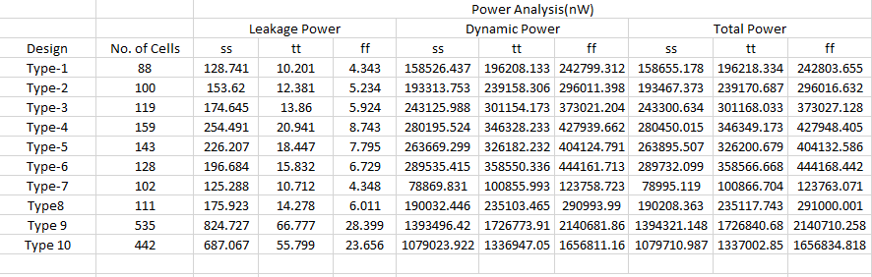

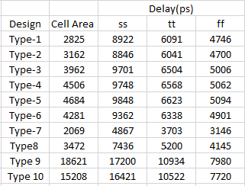

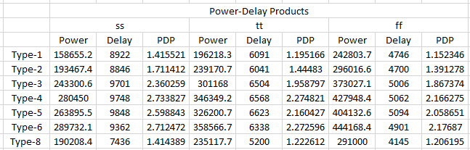 Power-Delay Product (10-12): Power and delay is converted into µW and µs respectively and then power-delay product is calculated.

Type 1 -Approximate Dadda Multiplier

Type 2- Approximate Wallace Multiplier

Type 3 - Accurate Dadda Multiplier

Type 4-Low power High Speed Accuracy Controllable Multiplier

Type 5- Vedic Multiplier

Type 6- Wallace Multiplier

Type- 7 Low power yet high speed approximate adder (16 bit)

Type8- Approximate dadda Multiplier (8-bit)- 3approx +1 accurate

Type 9 Accurate 16 bit dadda multiplier – 4 accurate 8 x 8 adder, one 16 bit vedic adder and two 24 bit vedic adder

Type -10 Approximate Dadda Multiplier 16 bit - 3 approx and 1 accurate dadda multiplier

ss denotes slow standard cell library

tt denotes typical standard cell library

ff denotes// fast standard cell library

From the above graphs it is found the dadda multiplier uses least number of cells for the equal accuracy. Approximate dadda multiplier utilizes least area and has least critical path delay. Power-delay product is also least making it a better architecture as compared to other kinds of multiplier architecture.

### **Graphs :-**

**Conclusion**

Using the **MATLAB** Pre defined functions we have compressed a 32*32 pixel image and then using approximate multiplier (8-bit approximate dadda multiplier) we tried to optimise that result.

So the Original pic that we have taken for operation is.....



**Fig1 :- Original 32*32 pixel image of size (617 bytes)**

Then using the inbuilt function of matlab (blockproc) we converted the image into 8*8 DCT blocks, then we apply the compression algorithms .

Then the pic after matlab compression is :-



**Fig2 :- Matlab 32*32 pixel Compressed Image of size(605 bytes)**

Then we make use of 8-bit approximate dadda multiplier (using 3 approximate 4-bit and one accurate 4-bit dadda multiplier) to get the optimised results .

Then the image after compression is :-



**Fig :- 32*32 Compressed Pic after using Approximate Multiplier(614 bytes)**

**Limitations**

The result thus obtained by the approximate multiplier is not always accurate and is approximated. Approximated results may not be useful for highly accurate applications. This multiplier can be used for error tolerant applications like image processing.

**Reference**

[1] S. Venkataramani, V. K. Chippa, S. T. Chakradhar, K. Roy, and A.Raghunathan. “Quality programmable vector processors for approximatecomputing,” *46th Annual IEEE/ACM International Symposium on* *Microarchitecture (MICRO),* pp. 1-12, Dec. 2013.

[2] H. R. Mahdiani, A. Ahmadi, S. M. Fakhraie, and C. Lucas, “Bio-Inspired imprecise computational blocks for efficient VLSI implementation of soft-Computing applications,” *IEEE Transactions on Circuits and* *Systems I: Regular Papers,* vol. 57, no. 4, pp. 850-862, Apr. 2010.

[3] S. M. Sunil Dutt, Sukumar Nandi and Gaurav Trivedi ―A Comparative Survey of Approximate Adders‖ 26th International Conference Radioelektronika (RADIOELEKTRONIKA), pp. 61 - 65, Apr 2016.

[4]Amir Momeni; Jie Han; Paolo Montuschi; Fabrizio Lombardi, ―Design and Analysis of Approximate Compressors for Multiplication‖, IEEE Transactions on Computers Year, Vol. 64, no.4, pp. 984 - 994, Feb. 2015.

[5] Tongxin Yang,,Tomoaki Ukezono, Toshinori Sato- “A Low-Power High-Speed Accuracy-Controllable Approximate Multiplier Design” [2018 23rd Asia and South Pacific Design Automation Conference (ASP-DAC)](https://ieeexplore.ieee.org/xpl/conhome/8291862/proceeding).

[6]J Ramaswamy,S Nagarajan- “Approximate Multiplier Technique- A Survey”,

International Journal for Research in Emerging Science and Technology, VOLUME-4, ISSUE-5, MAY-2017.

[7] A. Momeni, J. Han, P. Montuschi, and F. Lombardi, “Design and analysis of approximate compressors for multiplication,” *IEEE Transactions on* *Computers,* vol. 64, no. 4, pp. 984-994, Apr. 2015.

[8] K. C. Bickerstaff, E. E. Swartzlander, and M. J. Schulte, “Analysis of column compression multipliers,” *15th IEEE Symposium on Computer* *Arithmetic,* pp. 33-39, Jun. 2001.

[9] Premananda B.S., Samarth S. Pai , Shashank B. , Shashank S. Bhat,” Design and Implementation of 8-Bit Vedic Multiplier”, International Journal of Advanced Research in Electrical, Electronics and Instrumentation Engineering, Vol. 2, Issue 12, December 2013,pp-5877-5882